Want a Taxi App http://click-labs.com/landing/taxi-app.php

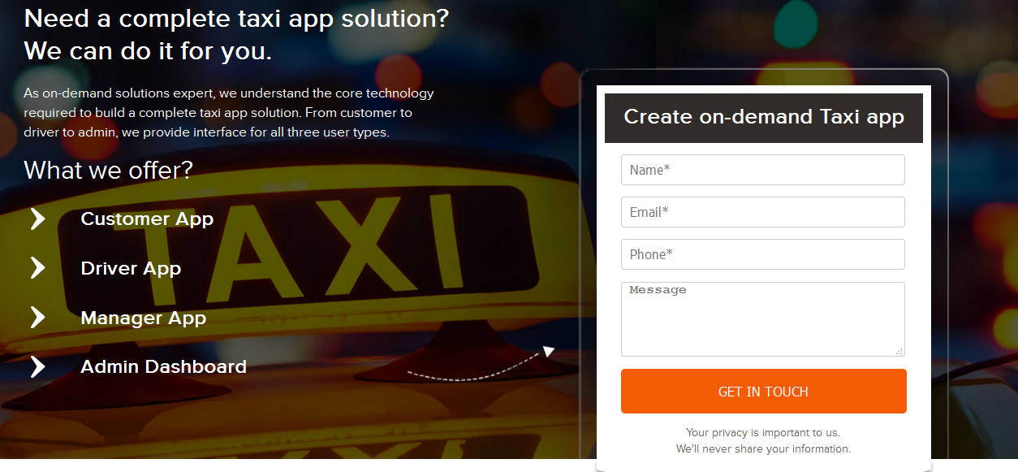

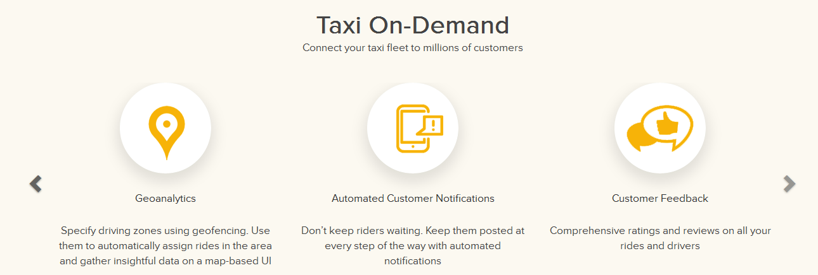

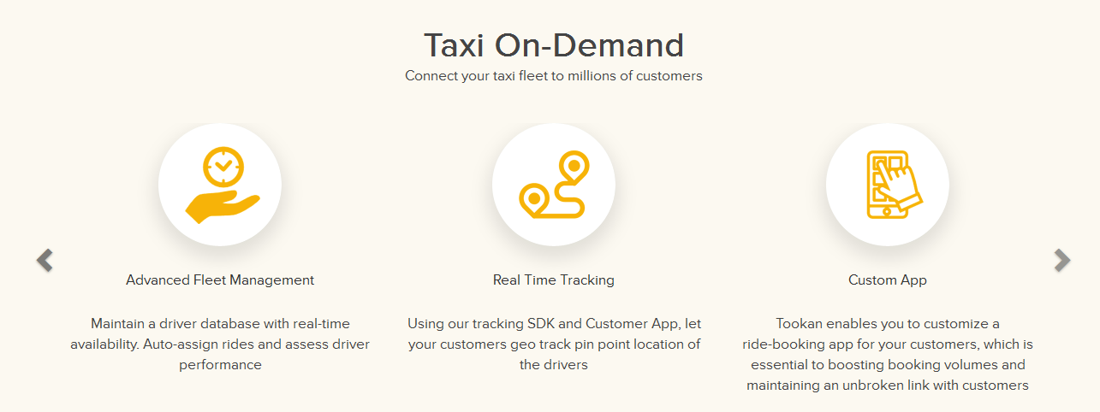

**About Relinns**

______ offers enterprise grade technology solutions with a focus on mobility. We are market leaders in delivering mobility solutions to entrepreneurs and enterprises looking to provide an omni channel experience to their customers. Our mission is to engineer and maximize mobile ROI.

Taxi

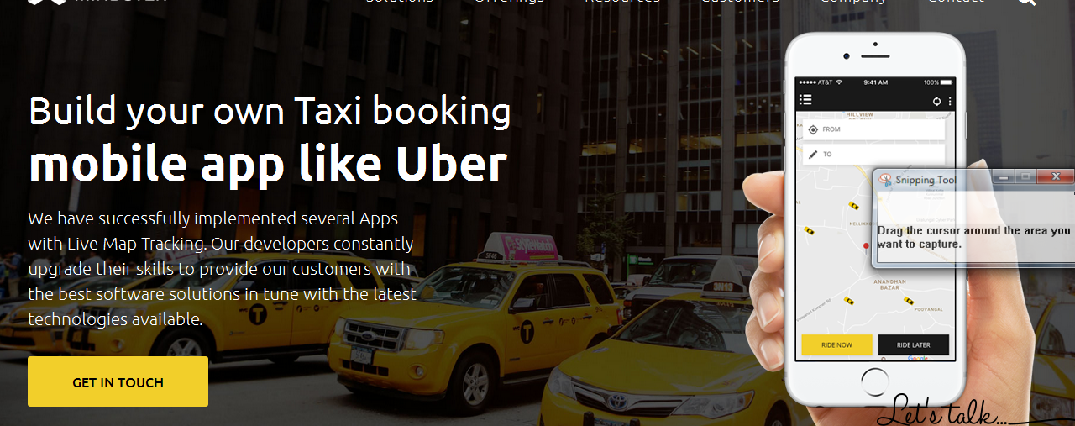

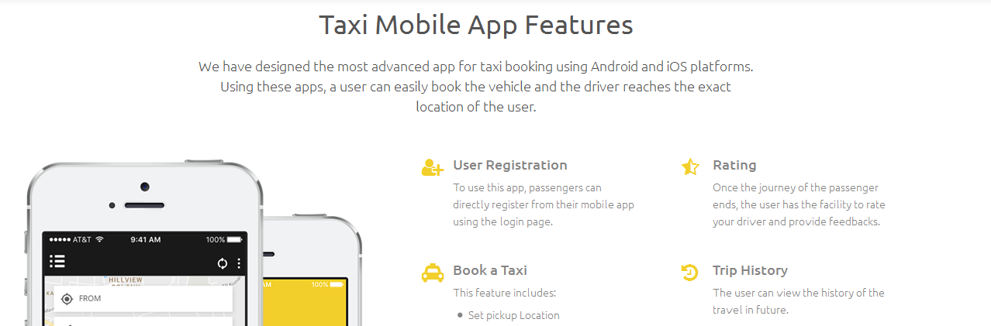

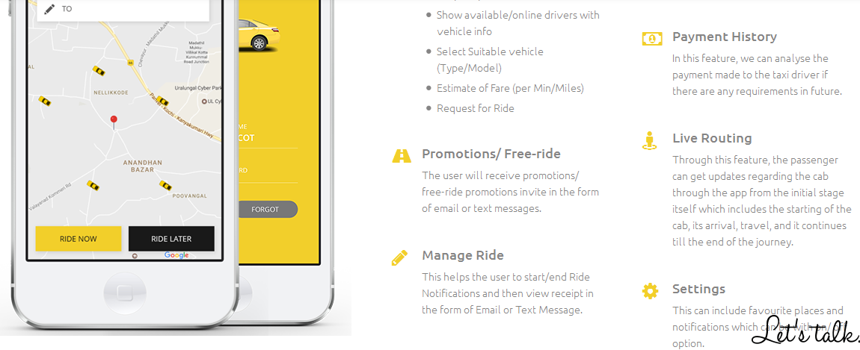

Why Choose Us?

